Project Design Phase-II
Data Flow Diagram & User Stories

Date | 05-Oct-2026
Team ID | SWTID-2026-4623
Project Name | AI BlogNest API
Maximum Marks

Data Flow Diagrams:
A Data Flow Diagram (DFD) is a traditional visual representation of the information flows within a system. A neat and clear DFD can depict the right amount of the system requirement graphically. It shows how data enters and leaves the system, what changes the information, and where data is stored.

Level-0 DFD (Context Diagram) of AI BlogNest API:
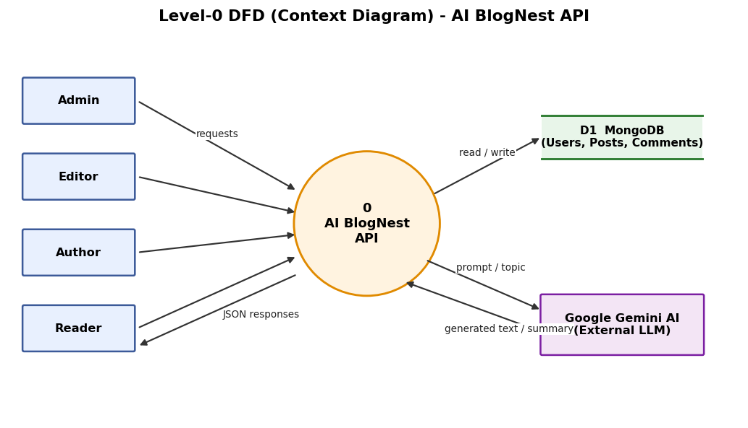
Level-1 DFD of AI BlogNest API:
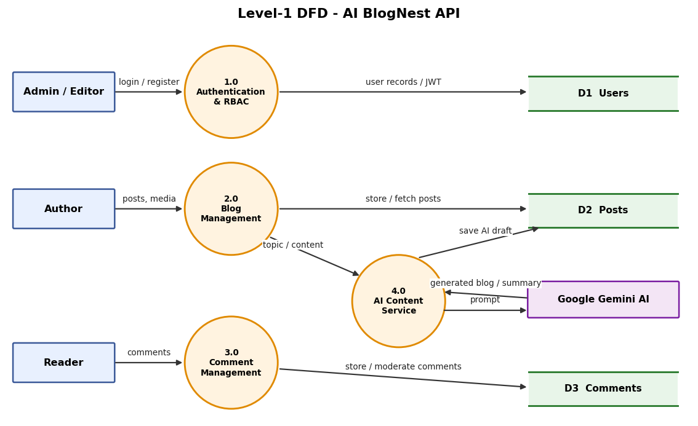
Data flow: Admin, Editor, Author and Reader send requests to the Express.js API. Process 1.0 verifies identity and role (JWT) against the Users store; process 2.0 stores and fetches posts; process 3.0 handles comments and moderation; process 4.0 sends topics / content to Google Gemini AI and returns generated blogs or summaries.
User Stories
Use the below template to list all the user stories for the product.
User Type | Functional Requirement (Epic) | User Story Number | User Story / Task | Acceptance criteria | Priority | Release
All Users | User Registration & Login | USN-1 | As a user, I can register with my name, email and password so that I get an account on BlogNest. | Account is created, password is stored hashed (bcrypt) and a success response is returned | High | Sprint-1
All Users | User Registration & Login | USN-2 | As a registered user, I can log in with email and password so that I receive a JWT token for protected routes. | Valid login returns a JWT; wrong credentials return an error | High | Sprint-1
Admin | Role Management | USN-3 | As an admin, I can view users and change their roles (Admin, Editor, Author, Reader) so that permissions are controlled. | Only an Admin token can change roles; other roles get 403 Forbidden | High | Sprint-1
Author | Blog Management | USN-4 | As an author, I can create a blog post (title, content, photo path) so that I can publish my ideas. | Post is saved with my user ID and timestamps and appears in my list | High | Sprint-2
Author | Blog Management | USN-5 | As an author, I can update or delete my own posts so that I can keep my content correct. | Only the owner (or Admin/Editor) can edit or delete; others get 403 | High | Sprint-2
Author | Media Handling | USN-6 | As an author, I can attach a media path / metadata to a post so that images are linked to my content. | Photo path is stored and returned with the post | Medium | Sprint-2
Reader | Public Access | USN-7 | As a reader, I can fetch the list of published posts and open a single post so that I can read content. | GET routes return published posts in JSON | High | Sprint-2
Reader | Discovery & Search | USN-8 | As a reader, I can search and filter posts by category or tag so that I can find content easily. | Search/filter returns only matching posts | Medium | Sprint-3
Reader | Comments | USN-9 | As a logged-in reader, I can add a comment to a post so that I can share feedback. | Comment is saved against the post and my user ID | High | Sprint-3
Editor | Editorial Workflow | USN-10 | As an editor, I can review pending posts and change their status (Draft, Pending, Scheduled, Published) so that only approved content goes live. | Status update works for Editor/Admin only and is reflected in the post | High | Sprint-3
Editor / Admin | Comment Moderation | USN-11 | As an editor or admin, I can mark comments as approved, pending or spam and delete malicious ones so that discussions stay clean. | Moderation flag is updated; spam is hidden from readers | Medium | Sprint-3
Author | AI Blog Generation | USN-12 | As an author, I can send a topic to the AI endpoint (/api/ai/generate-blog) so that a full blog draft is generated by Gemini AI. | API returns a structured blog draft that I can save as a post | High | Sprint-4
Author | AI Summarization | USN-13 | As an author, I can send long content to /api/ai/summarize so that I get a short summary. | API returns a concise summary of the given text | High | Sprint-4
Author | Analytics | USN-14 | As an author, I can see likes and engagement of my posts so that I can measure post performance. | Likes count and post data are returned for my posts | Medium | Sprint-4
Admin | Security & Logging | USN-15 | As an admin, I can rely on validation, sanitization, rate limiting and logs so that the system stays secure. | Invalid or malicious input is rejected; errors are logged centrally | Low | Sprint-4

